**ASSIGNMENT 9.2**

Twitter Data Stream with FLUME.

Installed flume via given method on ubuntu .

flume.conf

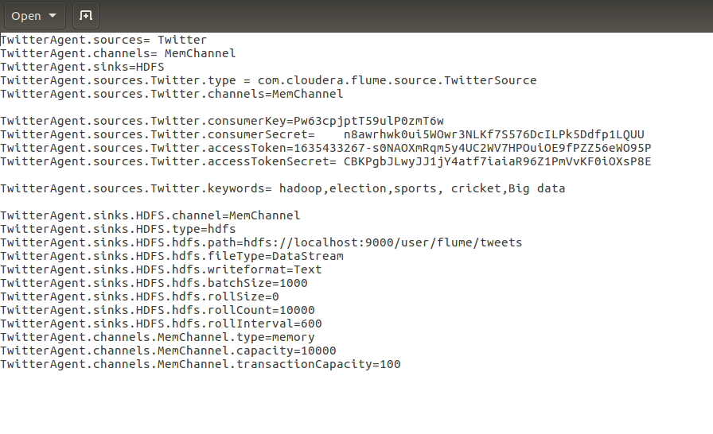

Creating the twitter app.

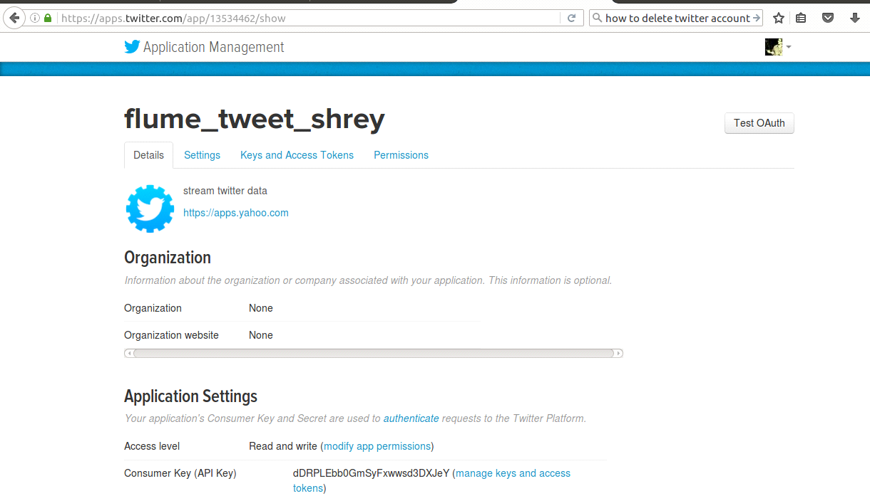

Running the flume agent :

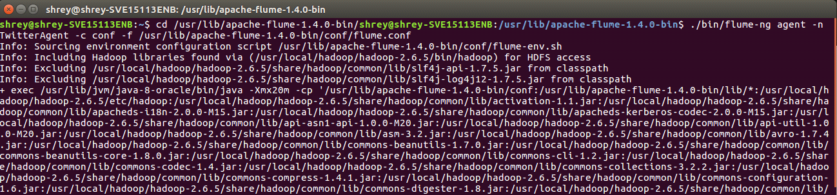

Checking on HDFS :

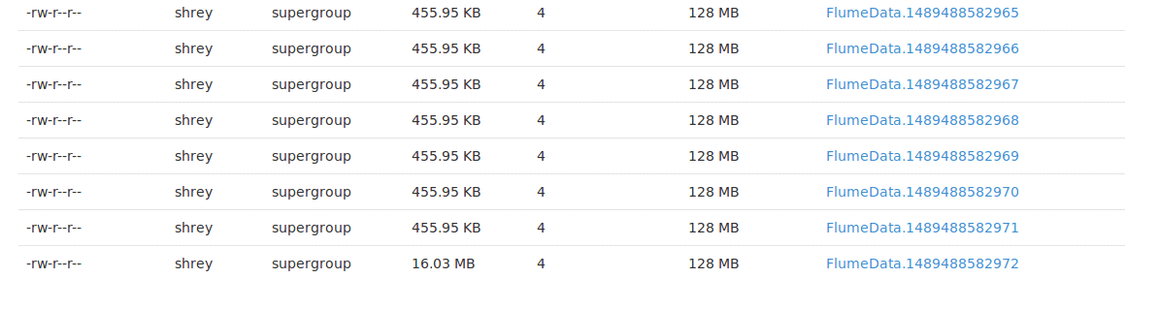

On opening the FlumeData file we can see that DATA STREAMING has started and the keeps on happening until and unless the the streaming is stopped (CTRL + C).

